I³OO (Integral Impact Investment Outcome Objectives Example)

Introduction:
This “case” I³OO is derived from the preceding discussions with a company and is submitted to X for final approval in parallel with any loan/funding agreements. It follows similar iterative lines and stages of development as such legal loan documentation including final sign-off by the company management.
Component parts of the below can become part of the covenant package within the main legal agreement and be directive within the use of proceeds.
Overview & Key Themes:
The company operates in several geographies and jurisdictions that allow for specific considerations to be taken into account at local vs. group levels.
During the DD and deep dive culture identification process, several areas were highlighted and now agreed for change to enable the company to deliver and reach its holistic objectives. We looked at the degree of the client dimension e.g. retention and revenue, affected / influenced by the organisational culture. We identified the key levers within the organisational culture that can and will effect strategic change.
Culture Diagnostic:
Using the CVF (Competing Values Framework) below, the Company is considered to be mainly influenced by “the market culture” archetype. Given their target clients and the nature of the highly competitive marketplace, this position is appropriate, particularly in those markets where the company is still fighting for market share.
In the two markets where the company is already the clear market leader, a more balanced archetype, such as “the clan culture” in particular would help the firm to develop the cohesion and team work required to innovate and become more effective. In addition, given its target acquisitions, the company is now moving from the “Go-Go” (Adizes) stage and a requirement towards prime as an imperative for a more managed and operationalised, structured form of growth from managing current assets and focus of client retention and cross sales opportunities.
Given its operational emphasis, “managing the control system” (chart below) is a strong area whilst the management functions supporting this aspect remains weaker.
The dominating influence from both the owner and the COO has created a “top-down” culture based on reliance on direction, instruction, agreement and decision making from those key members who also display behaviours similar to those seen inside “paternalistic” organisations.
A key growth imperative in preparation for the shift into “prime” will require a more decentralised, management and employee empowered and engaged culture that can drive creativity and innovation across the operations area and leadership dimensions. This will entail building a “learning organisation” to support innovative and sustainable growth across all operational divisions as complexity will outstrip current management capacities in this area.

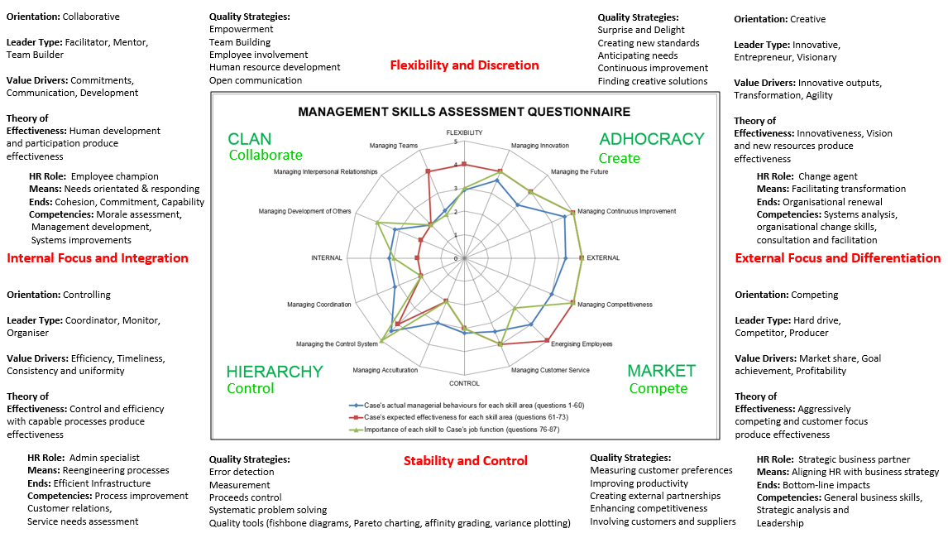

For true internalisation and to leverage a change in positive culture, a shift is required in the current economic model. Whilst ownership is concentrated to enable a clear line between risk and decision and to leverage further and future capital raisings for growth, building an extended sharing model that underpins the “we are all in the same boat” aspect of the new culture is required.
At this juncture, and following our culture survey, indirect ownership by staff is not expected, required or even wanted given the base hierarchy of the culture that prevails which is more aligned with direct economic rewards systems which covers immediate needs for self and family and provides direct financial control for discretionary spending and savings.
Given the disparate and at times varying performances between subsidiaries a system needs to be designed and aligned with overall performance that includes cross-subsidy to build team work / group cohesion and develop a more sharing and collaborative, solidarity culture which is clearly linked to end customer results/KPI’s .
As such, a transformative staff bonus pool (min. 5% of NOP) will be created and designed that delivers transparent financial inclusion and increased wellbeing across the entire staff spectrum. (Economic & Financial, No. 1 below).
The culture will also be required to become more balanced between internal operations and external imperatives, mainly customer growth and clear key KPI’s/customer.
The company will re-design and re-energise its community activation and development programs across the group around key themes and values using a “bottom-up” needs identification approach that connects the organisation with the community to be made self-sustaining over time which is currently not the case. Current activity is non-strategic and not connected to the “heart & soul” of the organisation. Disconnected as “the peoples network” and disperse in terms of activity i.e. no central core themes. E.g. in the Arts or main sport area linked to community.

Solutions:
During the DD process a number of specific key themes were identified and agreed:
General:
- The development of a balanced scorecard (Kaplan) is needed and is to be developed by the newly constituted board during X.

 |  | I³OO Agreement Road Map
Underlying Issue  L.A : Loan Agreement  Cov. Covenant  GS: Green Steward | Agreement  (Key high level agreements) |  | In  L.A. | Budget/Debit  (Cost of implementation) | Impact/ Credit  (Benefit from implementation) | KPI’s  (Key Performance Indicators) | Respon-  sible Party | Initiation  /start date  (Denotes time for initial implement-tation) | Implemen-tation | SDG’s
Environmental
1. GHG / carbon footprint could be improved in multiple areas at both at organisational and stakeholder levels. (1-6) | From “diesel to electric” green program |  | Cov | $700.000 | $200.000 | % of OPEX 50/50 | COO | 1-year | 10 years | 7,12,13,14
2. | Travel less / use conf. facilities |  |  | $100.000 | $200.000 | Miles / person | GS | 3-months | 5-years | 12,13
3. | Equipment recycling Audit |  | Cov. | $10.000 | $10.000 | Audit report on off-take programs | CFO | 12-months | 1-year | 9,12,13
4. | Offtake partners collaboration/integration |  |  | $5.000 | $50.000 | Tonnes/recycled | COO | 12-months | 1-year | 12,13
5. | Tower partner diesel to solar program |  |  | $50.000 | $100.000 | No. towers converted | COO | 24-months | 10-year | 12,13,14
6. | Handset recycling facilities |  |  | $50.000 | $200.000 | Carbon neutral handset goals | COO | 2-years | 10-years | 1,9,12,
7. Insufficient funding towards environmental projects (level to be understood/agreed). | Plant carbon sink plantations |  | Cov | $100.000 | $200.000 | No. Trees / acre | TBA | 2-years | 20-years | 13,14
9. Lack of training / awareness of environmental issues. | Training program on environmental issues for industry/company |  | Cov. | $20.000 | $400.000 | No. attended program / year.  OPEX savings | TBA | 1-year | 5-years | 9,12,13
10. Not high on the management agenda / strategy. | EXCO member responsible for area (Green Steward, GS) |  | Cov. | $2.000 | $0 | No. agenda items. Deliverables | CEO | 3-months | 1-year | 12,13,17
Human & Cultural
1. Lack of diversity in senior management team based on growth projections. | Hire 2 members, 1 for BD and Operations |  | Cov. | $300.000 | $0 |  | CEO | 12-months | 5-years | 8,
2. Little or no employee involvement in management. | Employee management representation |  | Cov. | $0 | $500.000 | Election by members | Board | 3-months | 20-years | 5,8,10, 16
3. Adversarial relationship policy towards suppliers. | CEO / COO No. 2’s appointments |  |  | $20.000 | $100.000 | Board to agree selection process | Board | 6-months | 1-year
4. Local management allocate for “pet projects” which lacks commercial cohesion or local empowerment. | Thematic brand aligned project plan |  |  | $200.000 | $0 | No. / program | HR / L&D | 12-months | 10-years | 1,11,
5. Succession planning and talent development required | L&D plan + appointment |  |  | $700.000 | $1,400.000 | Dev. Key program | Board | 6-months | 5-years | 16
6. No L&D strategy/budget | Management team leadership development |  |  | $70.000 | $100.000 | Appointment + no attended | HR | 12-months | 5-years | 16
7. Culture is driven locally with no purpose/mission for group. No consistent “bottom-up” intelligence to shape company. | Define Corporate Mission/Purpose statement |  |  | $2.000 | $0 | Communication + feedback | Board | 3-months | 5-years | 16
8. Base/core culture as yet not identified, articulated or communicated. | Culture survey (management & staff) |  |  | $10.000 | $50.000 | results | HR | 6-months | 1-year
9. Key cross cultural company value to be funded / implemented e.g. Arts development. | Arts Academy |  |  | $100.000 | $100.000 | Enrolment | Local MD’s | 12-months | 10-years | 10,11,
10. Develop Local ICT Talent | University Maintenance Engineering Program |  |  | $1.000.000 | $5.000.000 | No. enrolled & recruits | Local MD’s | 18-months | 3-years | 1,3,4,5,8,11
Social & Relational
1. Adversarial relationship policy towards suppliers. | Supplier collaboration plan |  |  | $5.000 | $25.000 | Feedback survey | COO | 6-months | 1-year | 12,16,17
2. Lack of commitment / coordination towards community development. | Coordinated community development plan aligned with brand & commercial drivers |  |  | $500.000 | $100.000 | No. projects | Board | 12-months | 10-year | 3,11,
3. Imbalanced approach towards employee development. | Support program for employees |  |  | $25.000 | $100.000 | Bottom up needs identification survey | Board | 6-months | 5-years | 3,4,10,
4. Commitments spread across too many areas/themes and not connected to corporate brand or culture. | Branding agent to position company around key themes |  |  | $25.000 | $100.000 | Appoint/instruct agent | Board | 6-months | 3-years
5. No strategic provision for family support. | Family programs |  |  | $100.000 | $200.000 | Bottom up needs identification survey | Board | 6-months | 3-years | 1,3,5,
Economic & Financial
1. Investment to generate 1,000 increase in employment based on current business plan. | Employment increase |  | Cov. | $10.000.000 | $40.000.000 | No. employees etc. | HR | 12-months | 3-years | 1,
2. Overly concentrated economic model which is not in line with values around sharing success and employee / community development. | Employee bonus pool |  | Cov. | $800.000 | $0 | 2% of EBIT | Board | 6-months | 1-year | 1,2,8,
3. Lack of CAPEX for “Green” strategies (link to Environmental). | Green Innovation Scheme |  |  | $100.000 | $500.000 | % / $ reduction in Energy usage | GS | 6-months | 10-years | 9,
4. Mainly “lip service” i.e. no funding for community development (link to Social & Relational). | See. No. 2 Social & Relational
5. ESG commitments has none or at best, little alignment with commercial goals/KPIs. | Overlay to No. 4 Social & Relational |  |  | $200.000 | 0$ | 1% of EBIT + Direct KPI links | CFO | 12-months | 3-years
6. Corporate objectives/KPIs entirely financially driven. | Suite of new KPI’s across ESG & Culture |  |  | $0 | $0 | Proposal by YE | Board | 6-months | 1-year | 10, 16
7. Develop new suite of operational/customer focussed KPIs that impact client behaviour | “Customer first” Delivery |  |  | $50.000 | $500.000 | Defined KPI’s | Board | 6-months | 1-year
 | Totals |  |  | $15,524,000 | $50,135,000

Impact Dashboard
Example Impacts:
Environmental:
1. (c) Handset recycling facilities.
Creating the circulation and down-cycling of handsets in their markets into the rural poor and those who cannot afford the capital outlay of a hand-set. This will enable these people to become connected, empowered and allow for the ongoing affordability to purchase Sim cards, thereby creating a client.
This project is centred on a number of key drivers:
- Collaborative partnership with existing mobile recycling charity. E.g. Oxfam
- Establish regional refurbishment facilities that repair and redistribute handsets.
- Build local distribution partners that reach the intended population.
Metrics:
No. of Handsets distributed
Company subscribers with such handsets
ARPU per subscriber
Milestones:
1, 5 and 10% of total subscribers
Outcome Measures:
No. of recycled handsets in circulation
Minutes / sim used and ARPU on such handsets
Implementation plan:
Board member X will take overall responsibility for implementation. Detailed plan is available separately which includes:
Partnership agreement with Oxfam
Location, hiring and trainee programs for repair/refurbishment centres
Specific handset security, anti-re-sell, lock-in features required
Local handset distribution partners
Fully aligned with “the peoples network” marketing plan/campaign
Contractual Arrangement:
1. Contract in place with e.g. Oxfam to supply handsets.
2. Earnings beyond x, then company must have refurbished x % of handsets from Oxfam. Then you must distribute x% of handsets into the community (jurisdictions / ratios based on market capitalisations.)

Human & Cultural:
7. Define Corporate Mission/Purpose statement.
The firm needs to define and articulate its core ambitions and key messaging internally to enable the foundations of its culture to be created. Once this is clarified, unification and reinforcement activities can be created and external messaging aligned.
Metrics:
Points of information
Milestones:
Communication point
Employee survey response
Outcome Measures:
Survey of %age of employees in 12 months cycles who state they understand corporate purpose / mission.
Implementation plan:
Board off-site session to brainstorm variables and variants
Align with balanced scorecard
Test with select employees (revise)
Agree communication points and modes
Launch and seek to align in all operational areas

Social & Relational:
5. Family programs.
It is apparent that the employees of the firm, on occasion, encounter different family issues that impact on their work and wellbeing. In each local office, the firm is to establish a mutual support program using a staff driven needs identification process. This means that different solutions may be established in each jurisdictions from child care support, wellness programs, help for the elderly etc.
Metrics:
No. of projects live
No. of people involved
No. of people affected
Milestones:
Projects started
Projects completed
Outcome Measures:
No of people positively impacted
Implementation plan:
Employee survey as to what would be the most useful/important in each locale
Build group of champions around each theme
Resource requirements, budgets and approval process.
Financial & Economic:
1. Employment (full-time)
The firm will take over or need to hire ca. 10.000 staff over the next 12-24 months given its expansion plans. This magnitude is transformational so will require the HR function to be strengthened.
Metrics:
No. of hires by category, sex, age, skillset, salary bracket etc.
Milestones:
Hired:
10.000 earning average of $10.000/person (ca. 25% above national average)
Managers:
10%
Disabilities:
Min.10%
Females:
Min. 30%
Female Managers:
Min. 30%
Managers with disabilities:
Min. 30%
Minorities:
Min. 30%
Outcome Measures:
Impact assessment: 4 X (attribution: 2 X towards local economy circulation and 2 X family members)
Implementation plan:
HR to instigate needs identification across the business areas
Build separate website for recruitment (internal & external)
Prepare hiring templates and job descriptions with local management
Build filtering criteria set for selections
Work with employment consultants how to filter available talent across regions/industries
Agree and implement interview process

